**Plane Sensor including Script node (javascript)**

Tests for the Plane Sensor including sending the movements of a plane to create levers for controlling other objects’ colors, rotations, etc.

**planeSensor_basic.x3d**

Red box is a fundamental Plane Sensor. Clicking on the red Box it can be dragged along the X-Y plane in the scene.

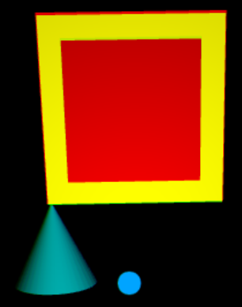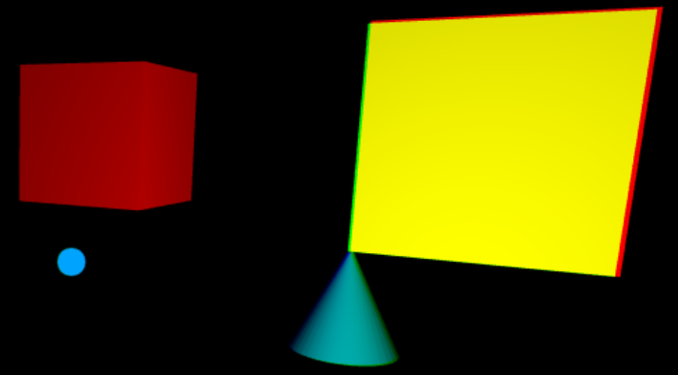

Since the blue icon dot moves inside a sphere (a constant number of units from the camera), but the plane sensor keeps the object in its X-Y plane, as the red Box moves further from its original position, the blue icon dot will not longer be over the red Box. The TouchSensor can be used instead to keep the blue icon dot and object aligned.

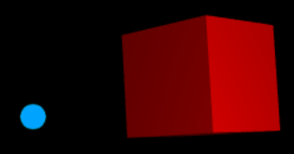

**planeSensor_MinMax.x3d**

Same as above demo, except the red Box is bound within +/- 3 in both the X and Y planes using the Plane Sensor’s min and max settings.

**planeSensor_trackpoint_changed.x3d**

This demo is from the Wed 3D’s test repository at: <http://www.web3d.org/x3d/content/examples/ConformanceNist/Sensors/PlaneSensor/>

Previous demo’s dragged the original object. Now, the yellow Box is the plane sensor, controlling the red Sphere which first appears at the center. Dragging along the yellow Box will move the red Sphere.

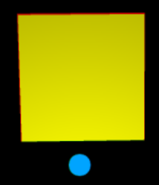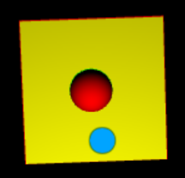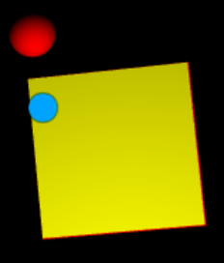

**planeSensor_SetRGB.x3d**

The Red, Green, Blue bars can be dragged to control the RGB of a Point Light. Initially, the bars are at (.5, .5, .5) though the Point Light color is at (1, 1, 1), so there will be a sudden color change.

There is a yellow Cone, magenta Cylinder and cyan Sphere plus a white bar. Dragging the R-G-B bars will change the Point Light’s color and impact the colors of the other objects.

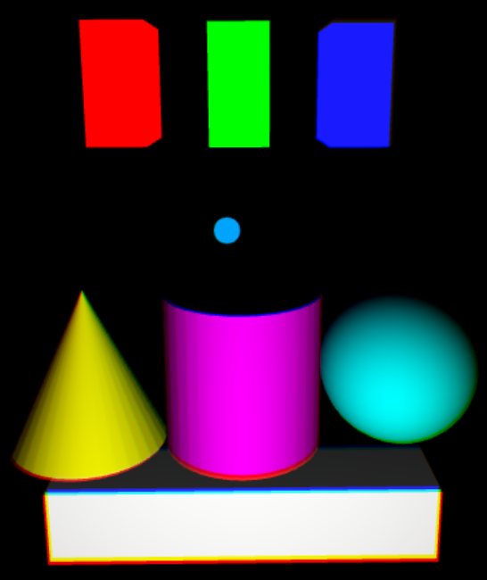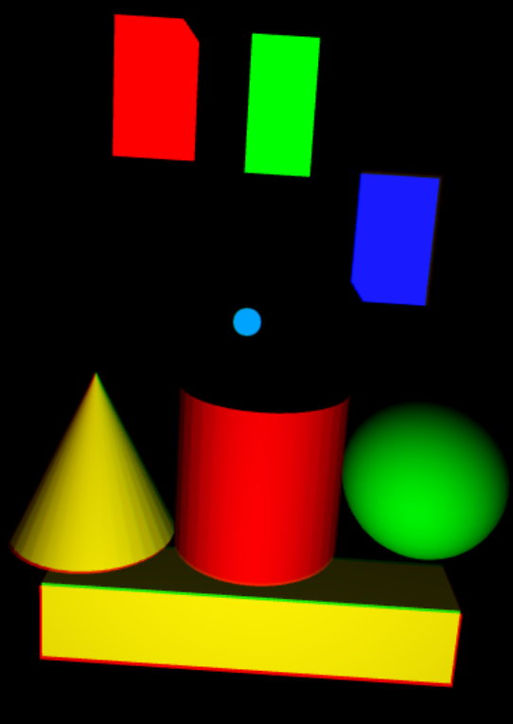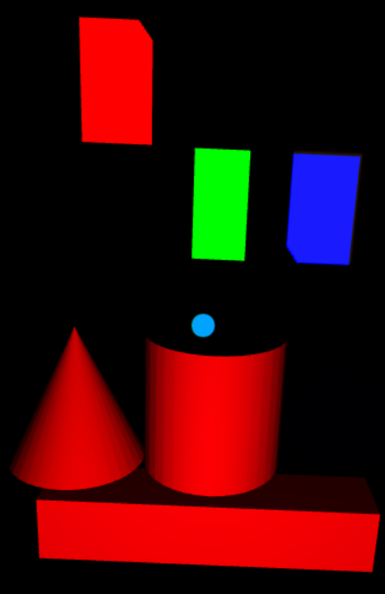

**planeSensor_SetRotations.x3d**

The X, Y and Z controls on the right will rotate the sphere on the left. The control range between π when dragged to the top, and –π when dragged to the bottom. The right image shows only a rotation around the X-axis.

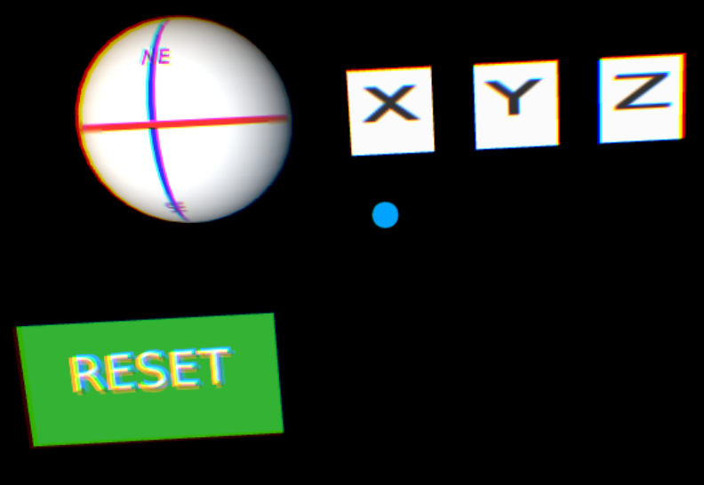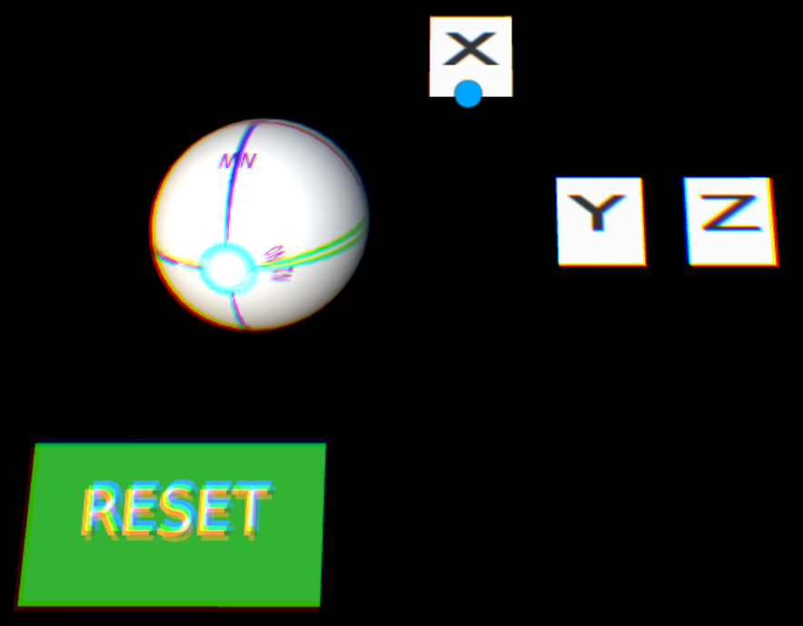

The ‘Reset’ button will return all the rotations and X-Y-Z controls to 0.

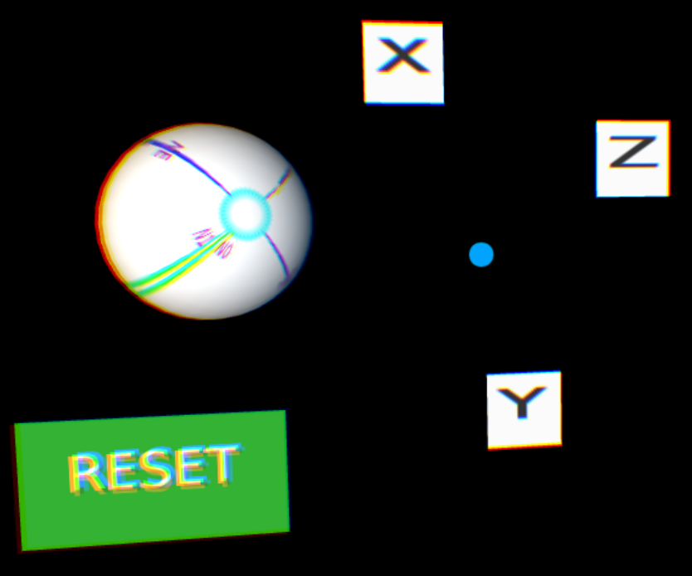

**planeSensor_MovieTexture.x3d**

Demo has two movies playing on their own plane that can be dragged around the scene. Each moview has an attached frame around it. The fish videlo will be in front of the frieght train but one could add a feture to change their order. The yellow Box and cyan Cone don’t do anything.

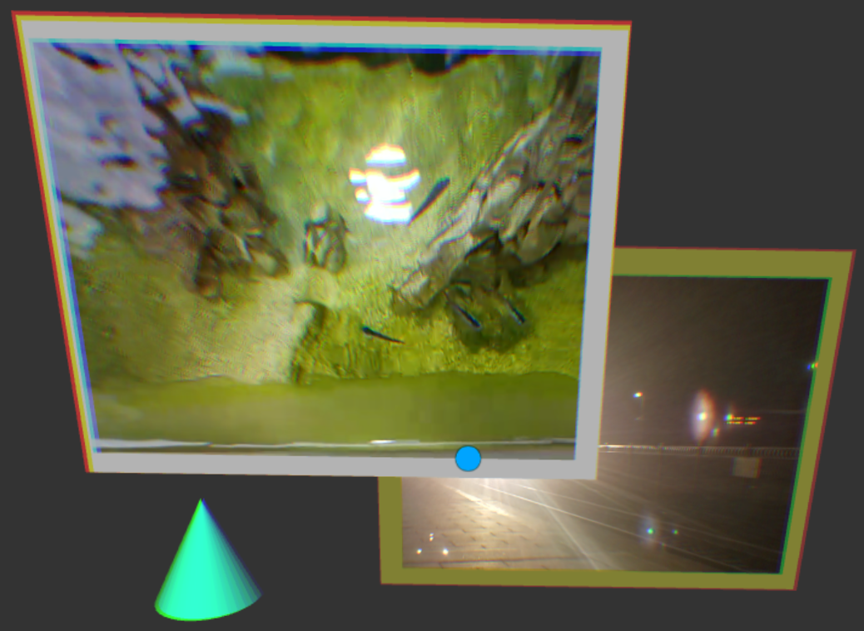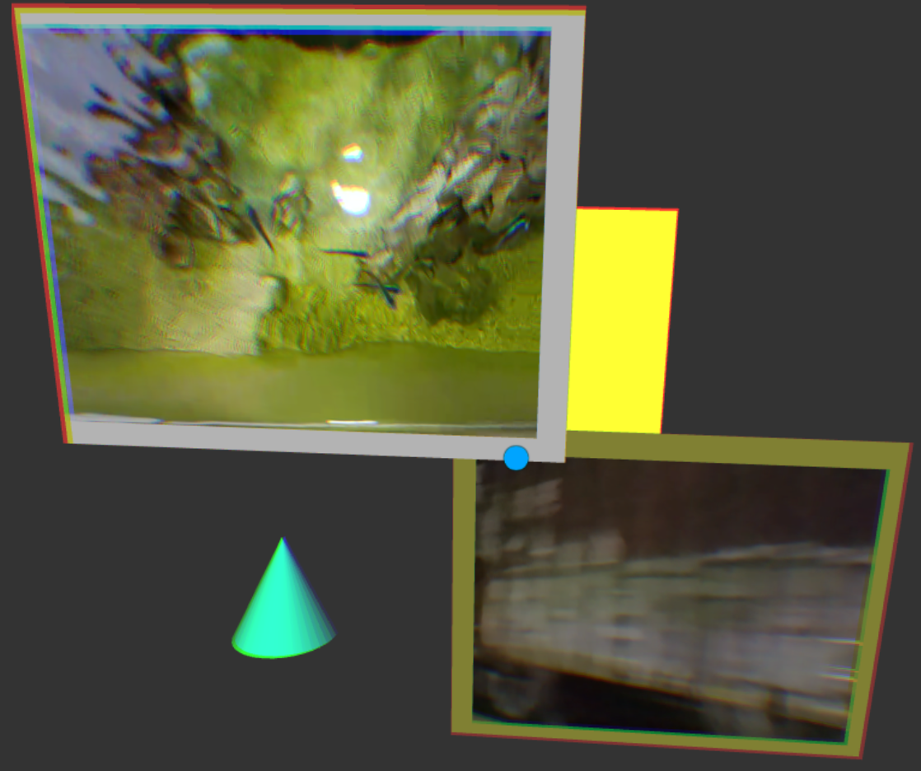

**planeSensor_Hockey.x3d**

This has some gaming structure. The yellow and black plane blocks the cylinder-shaped hockey puck. Pressing start begins the animation of the hockey puck with variable directions. If the puck gets by, then no points, but if the puck is stopped, then you get 1 point. Click on ‘Start’ each time.

Hardly a perfect game, but it gives some sense of possible game features using the Plane Sensor.

